Installation of Media Server using the defaults.

Ensure IE6 and Microsoft Office - PowerPoint 2000 is installed prior to installation. Power Point is used in the Media Services and IE 6 is needed to view the

Start by executing MediaServerSuiteSetup.exe

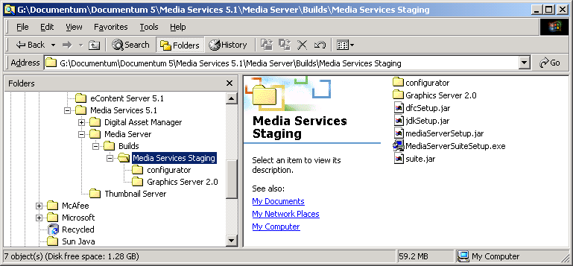

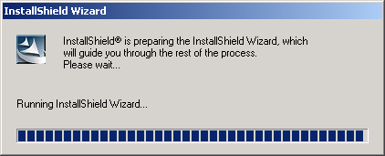

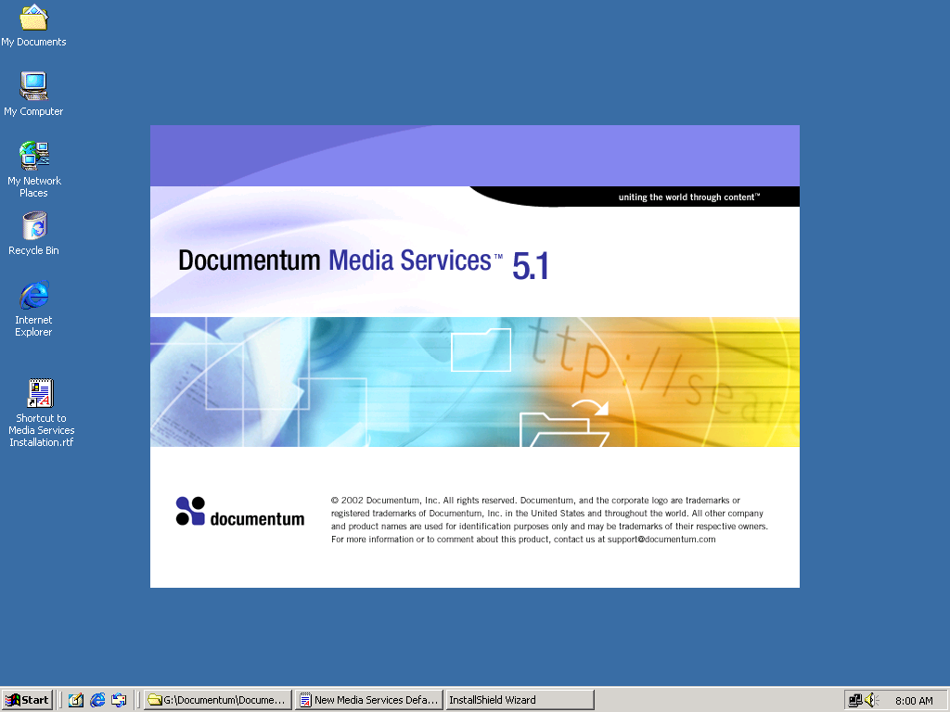

Select Documentation if needed then Next

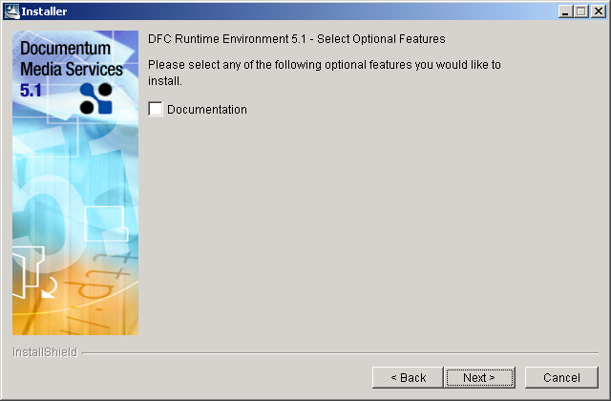

Select Next.

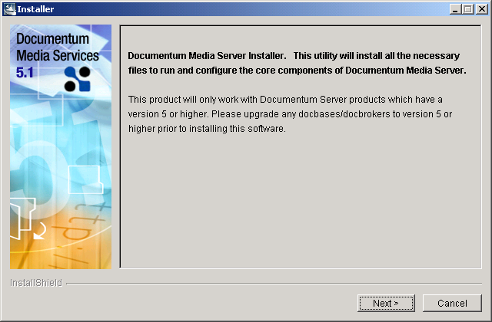

Select Next. Note that even if the path is changed, it is not reflected in a later screen.

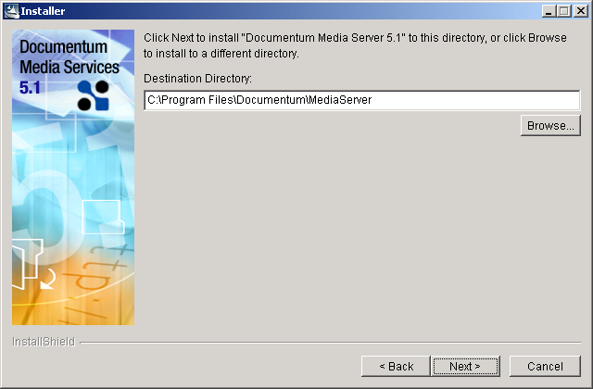

Verify the hostname is correct and select Next.

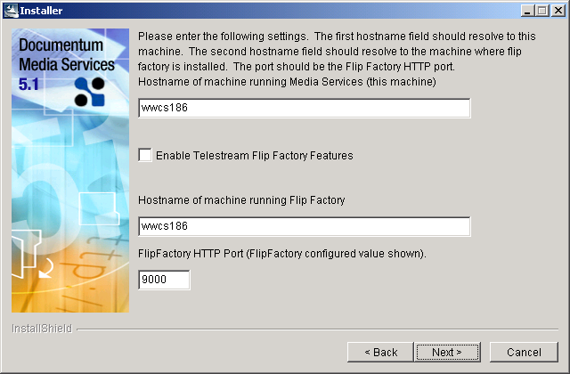

Note: If you changed the path to where the Media Server 5.1 will be installed, it will not be reflected in this screen. Just select Next.

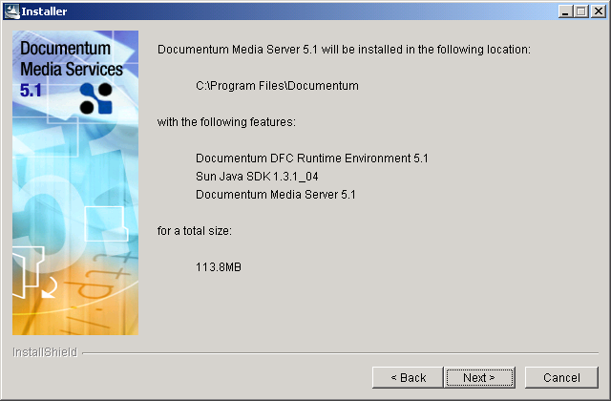

Select Yes.

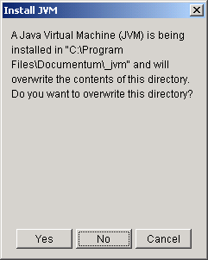

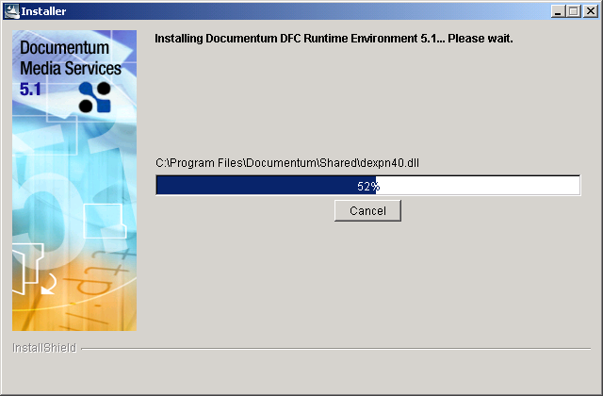

Select Yes.

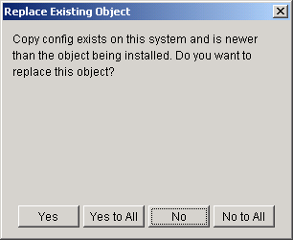

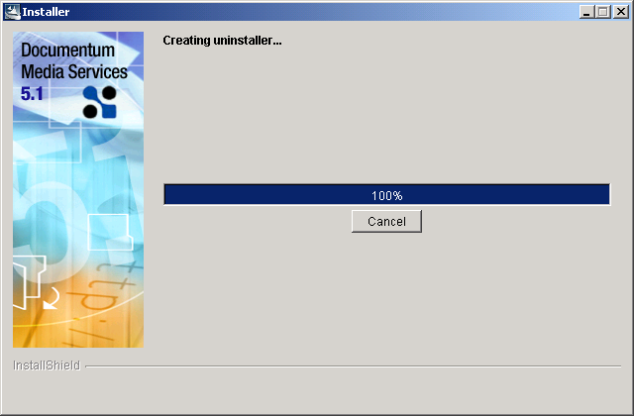

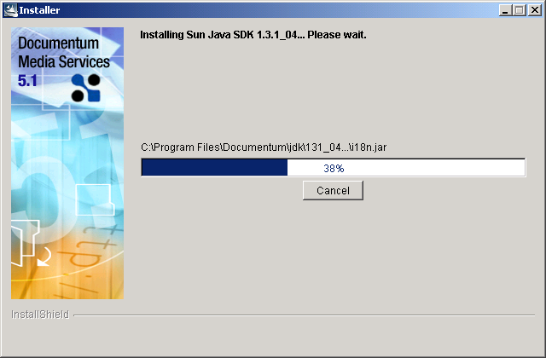

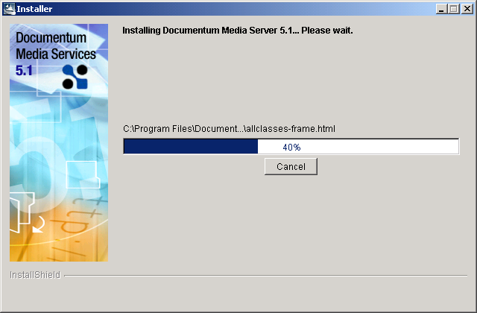

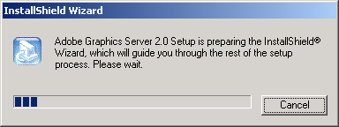

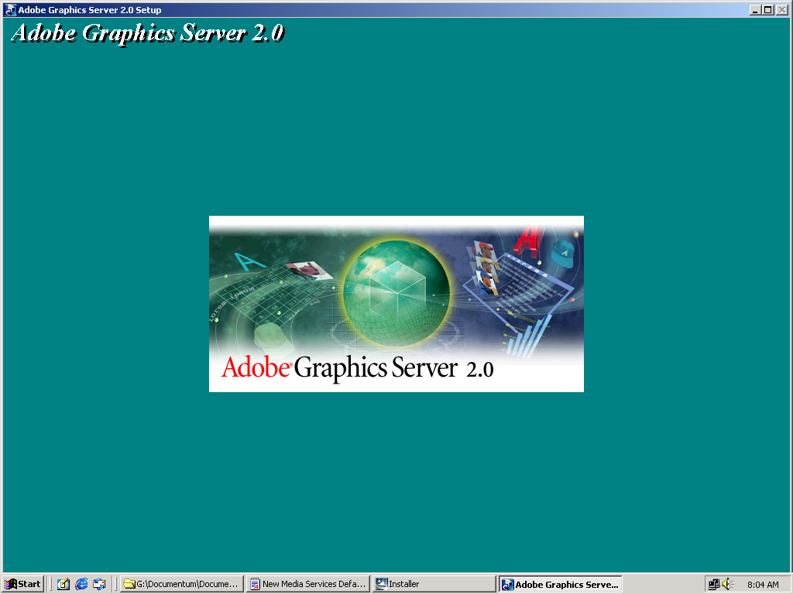

Select Yes.

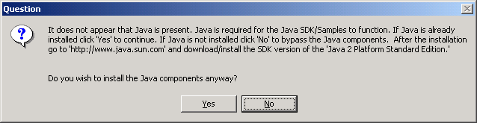

Select OK.

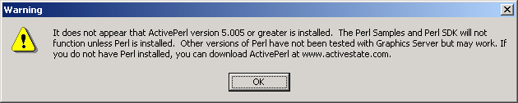

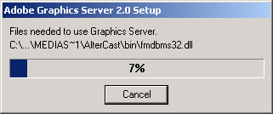

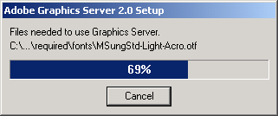

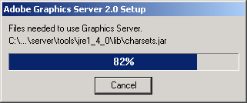

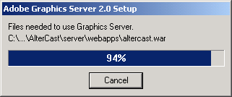

Select Finish.

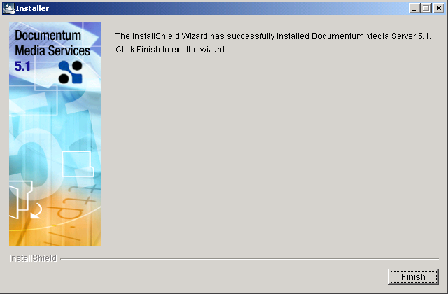

Go to Program Files then Add/Remove Media Services.

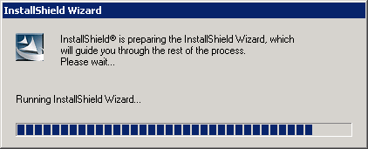

Select Next.

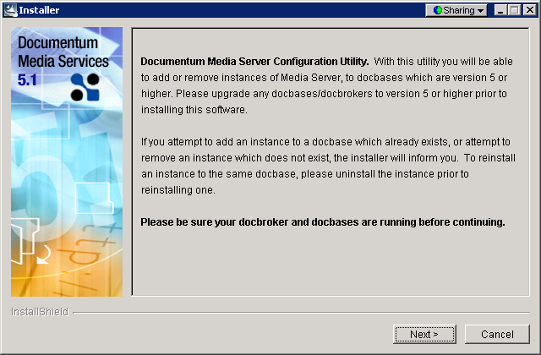

Select Next.

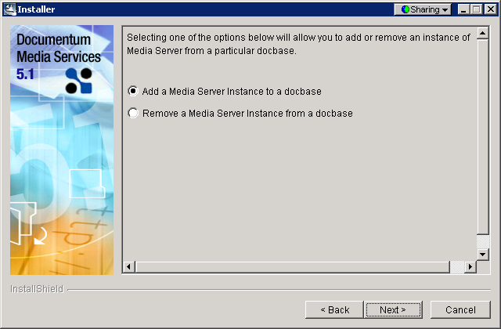

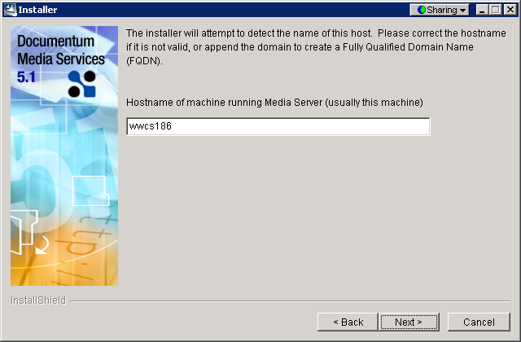

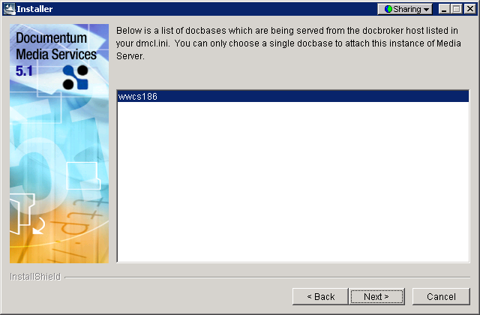

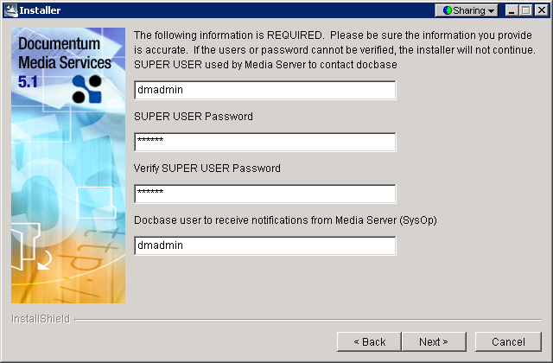

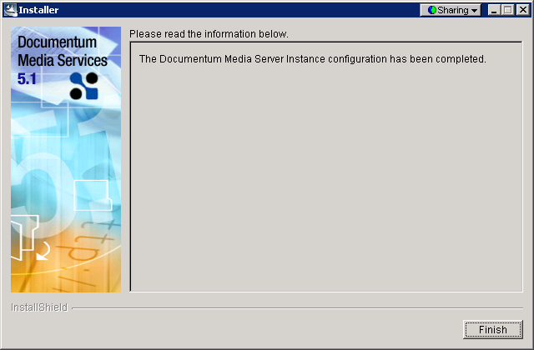

Verify the service is running.

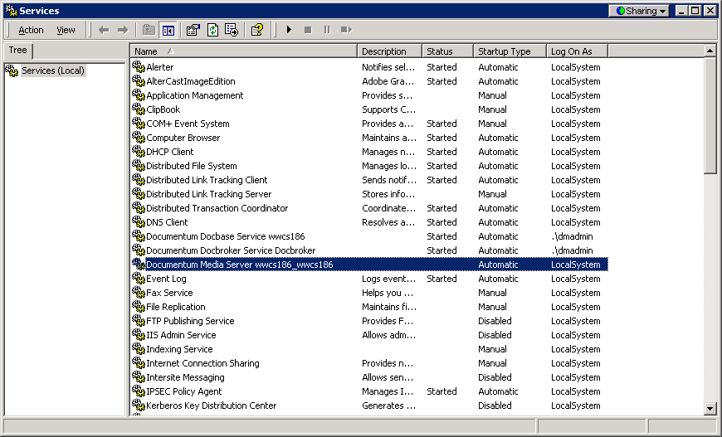

Installation of the Thumbnail Server
It will install for only existing docbases.

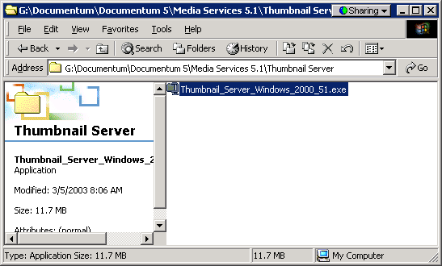.

UnZip in the c:\Documentum\product\5.1\thumbnail. Select Browse follow the path then Unzip.

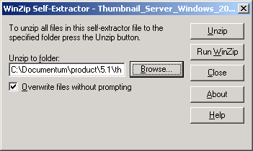

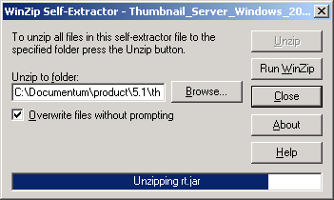

Select OK.

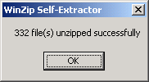

If installing the Application Server (Tomcat) on the same system, use different ports than the default. This is because Tomcat uses these ports. However it is not recommended to have the Application server on the same page.

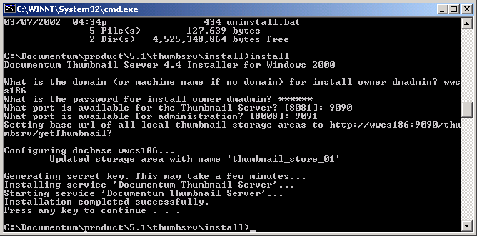

Installation of Java Development Kit.

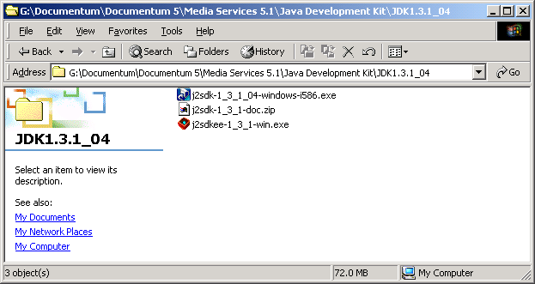

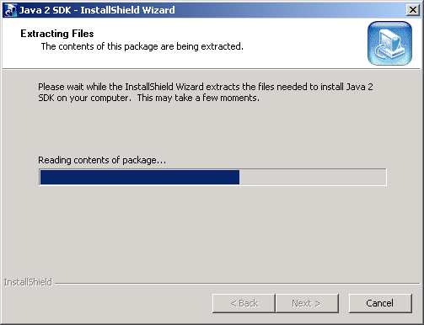

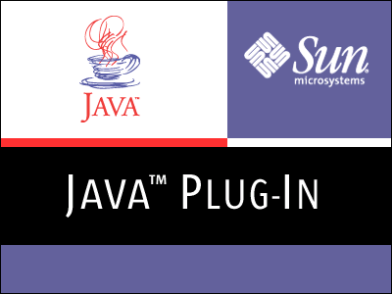

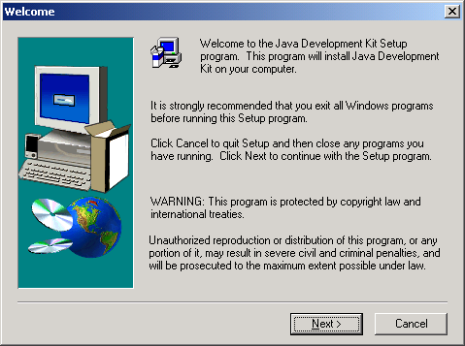

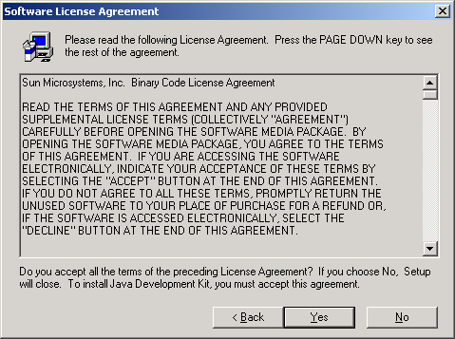

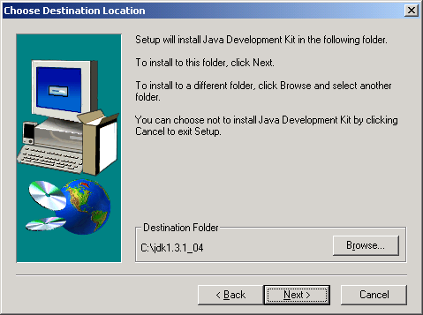

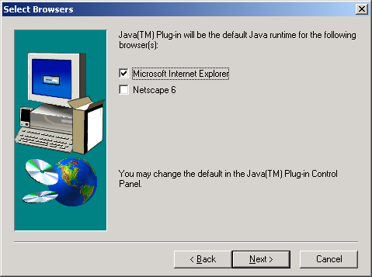

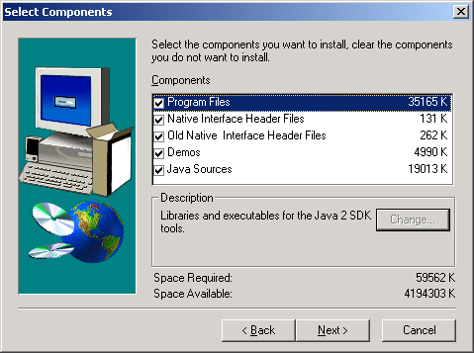

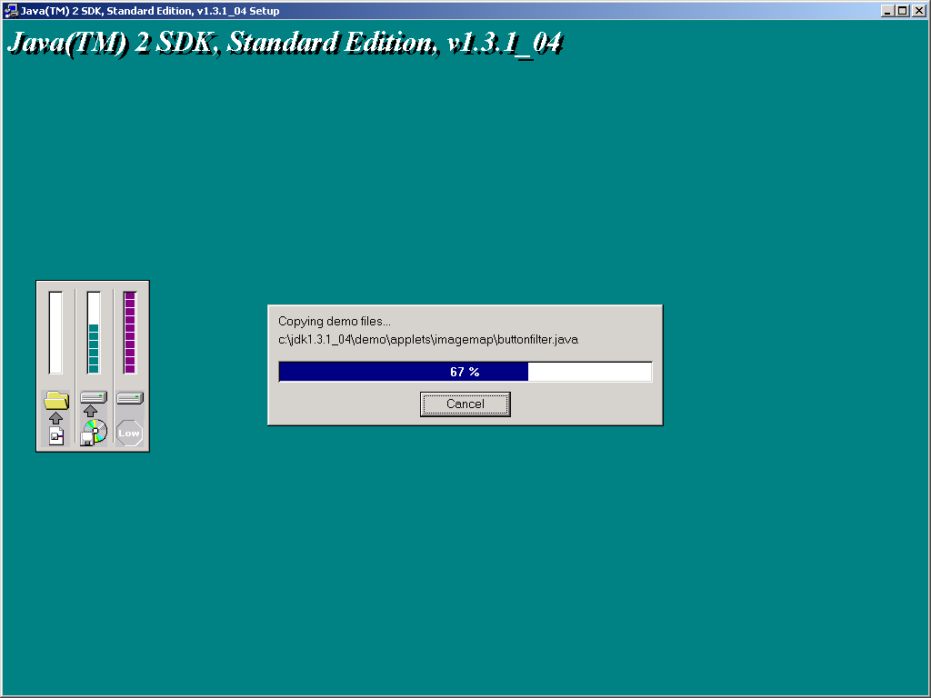
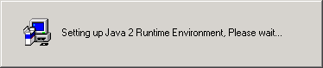

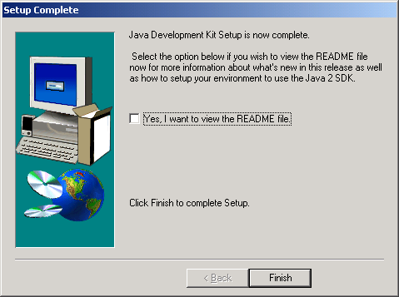

Installation of Apache/ Tomcat.

Run jakarta-tomcat-4.0.4.exe

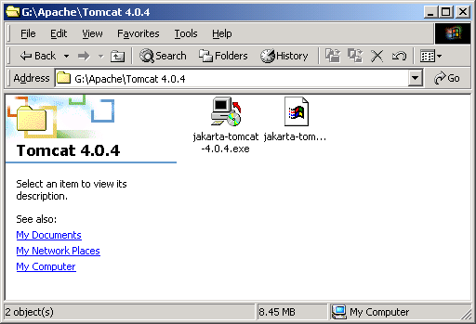

If you do not have the Java Development Kit installed, the error below will appear.

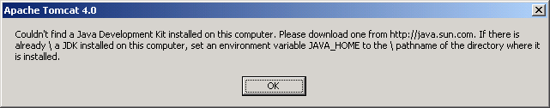

Select OK and install jdk1 3.1_04. See Installation of Java Developers Kit.

NOTE: Be sure and set the enviornment variables for the following:
JAVA_HOME C:\jdk1.3.1_04
CATALINA_HOME C:\Program Files\Apache Tomcat 4.0

Run jakarta-tomcat-4.0.4.exe

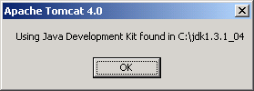

Select I Agree.

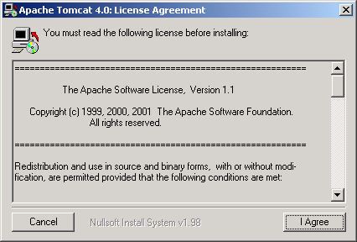

Select Next.

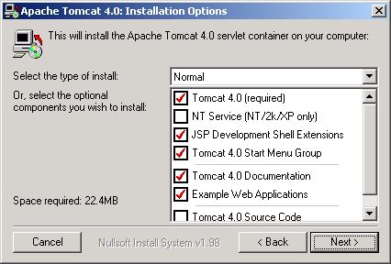

Select Install.

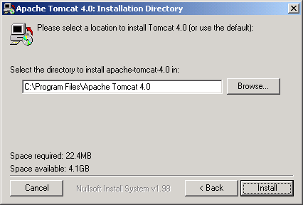

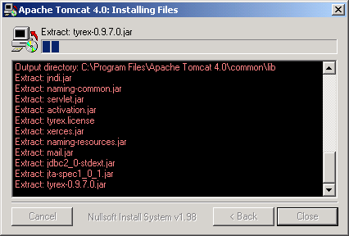

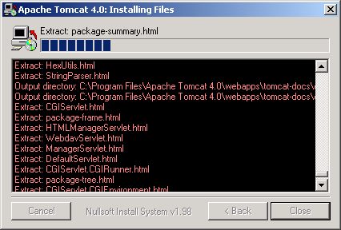

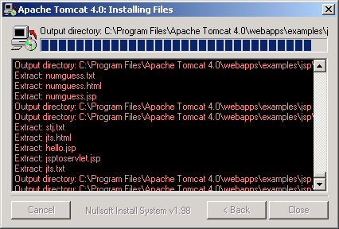

Select Close.

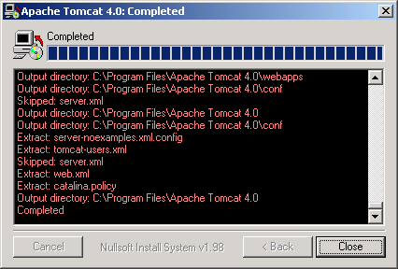

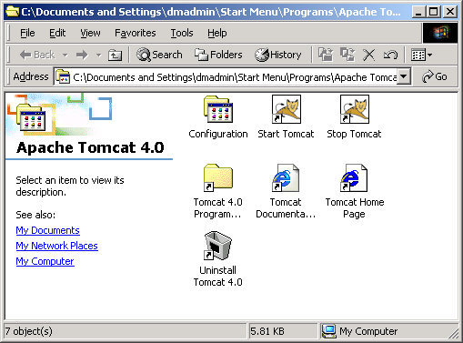

Go to the Tomcat installation folder and edit the file.
C:\Program Files\Apache Tomcat 4.0\conf

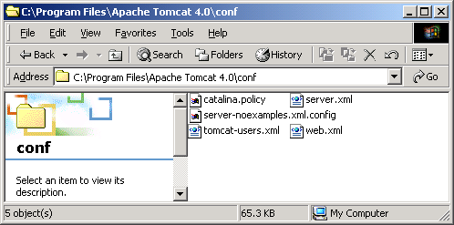

Edit the server.xml file. Search for the AJP. Look for the port associated with it. It should be 8009. Change it to 8909 and save the file.

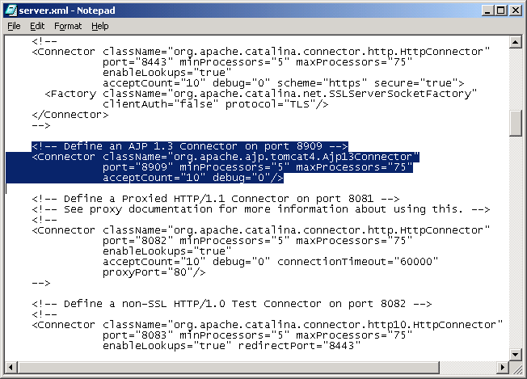

Also check the catalina.bat file for the class path information. Edit the file with notepad.
C:\Program Files\Apache Tomcat 4.0\bin\catalina.bat
Note: The class path that has been remarked out (rem) where the path has "~1" in the path names. That must be replaced with the full path. Also ensure the case sensitivity is correct. The set CLASSPATH above is a correct path.

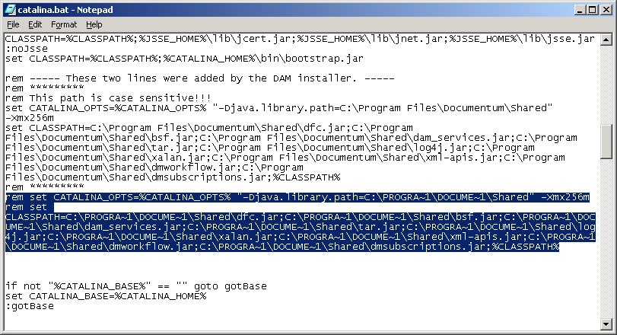

If you plan on dragging the Start Tomcat and Stop Tomcat icons from the Start /Programs menu, be sure and edit the Start Tomcat Properties Target to reflect: "C:\Program Files\Apache Tomcat 4.0\bin\startup.bat" or it will not work. Be sure to include the quotes.

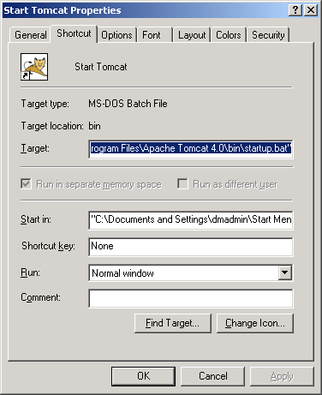

Start Tomcat through Start / Programs / Apache Tomcat 4.0 / Start Tomcat.

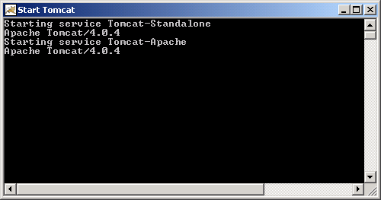

To test it is running, use a web browser and enter into the address:

http://<machinename>:9090 Example: http://wwcs186:8080

Installation of Digital Asset Manager.

Execute damSetup.exe

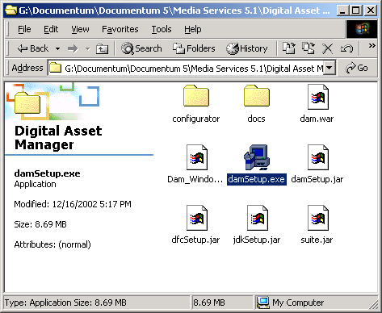

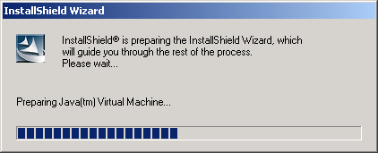

Select Next.

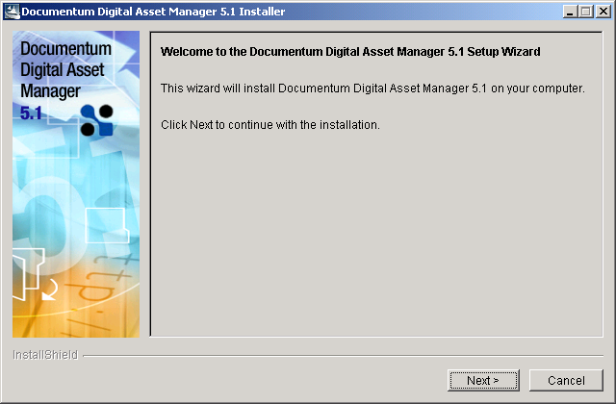

Select Next.

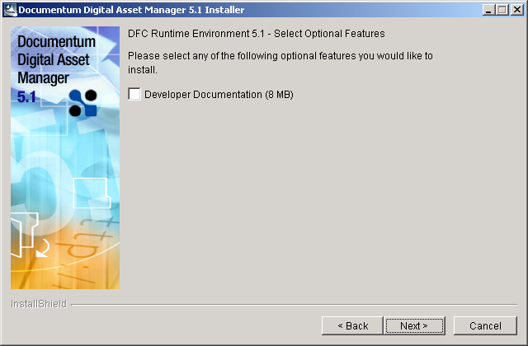

Select Apache Tomcat 4.0.4 then Next.

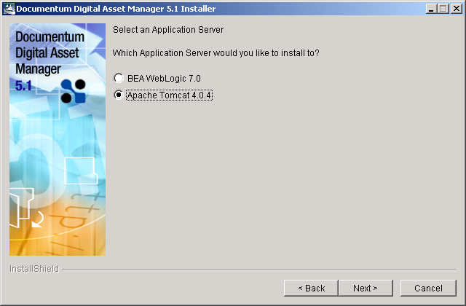

Confirm the the app server (Apache Tomcat 4.0.4) is stopped then select Next.

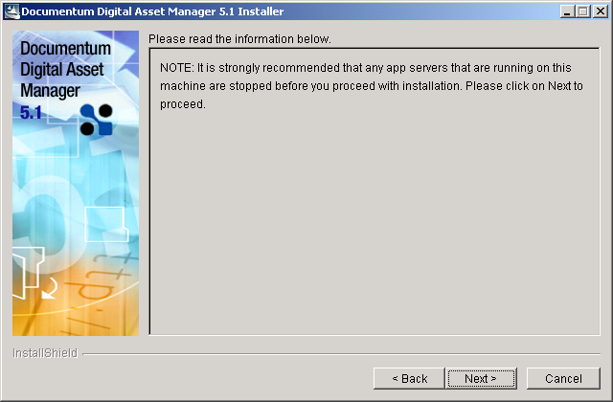

Select Next.

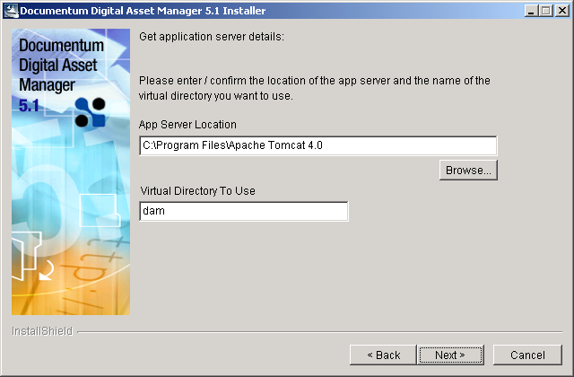

Select Next.

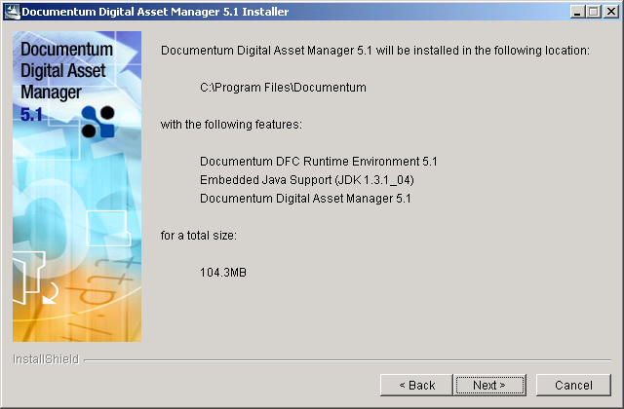

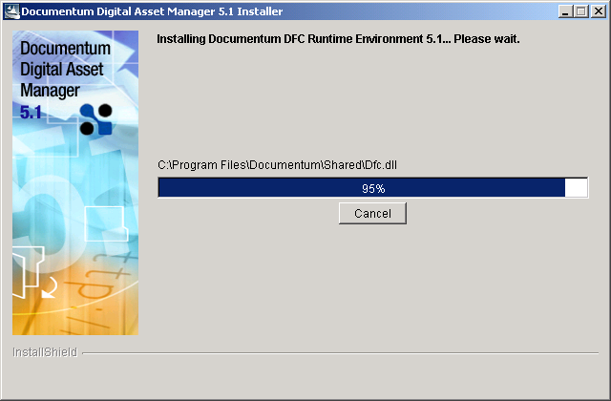

Select No.

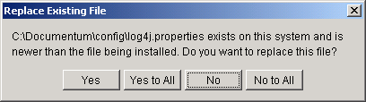

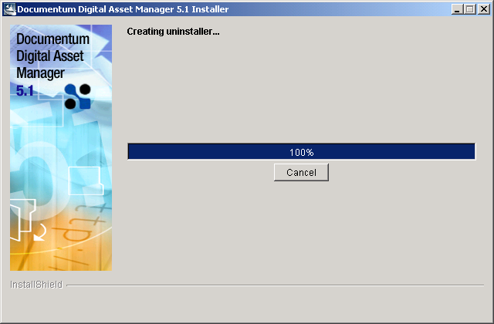

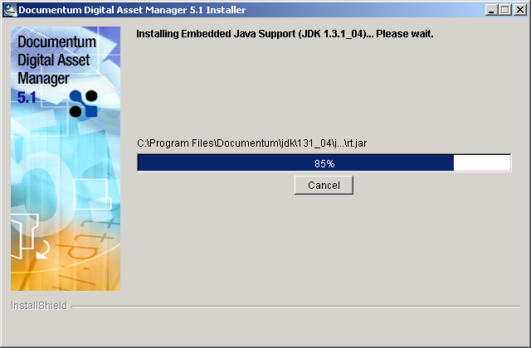

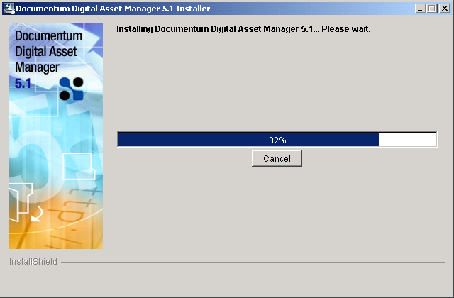

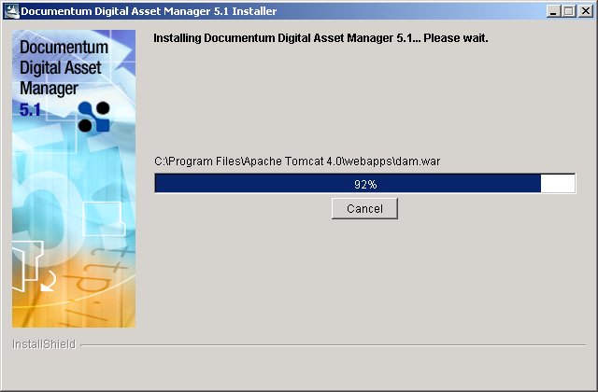

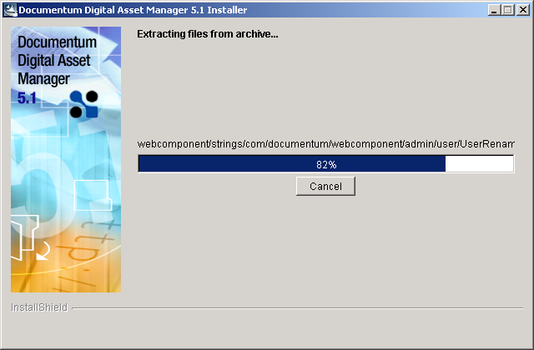

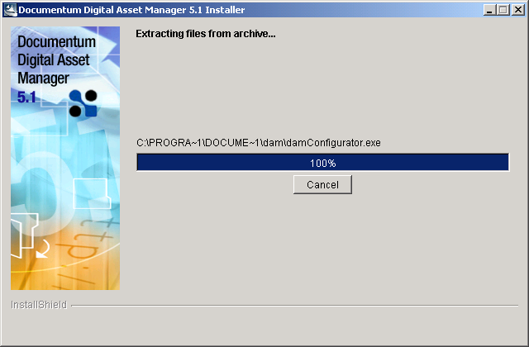

Select Next.

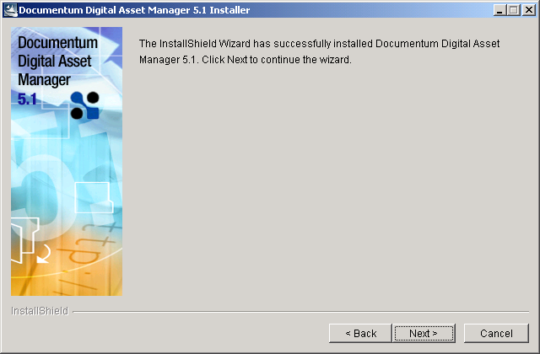

Select the appropriate item based on what you are doing, then Finish.

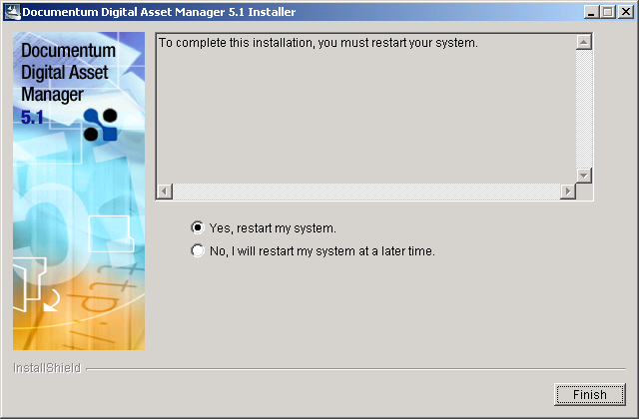

Configuring environment variables.

Right click on My Computer. Select Properties then select the Environment Variables.

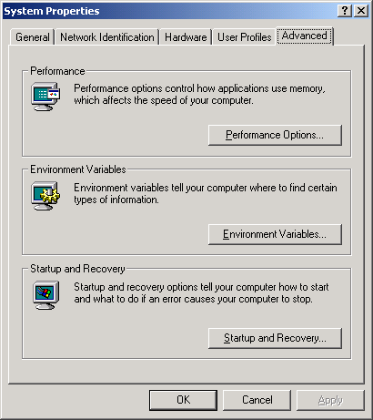

Select New button and enter the new variable and press OK.

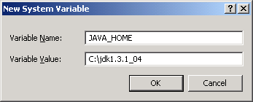

Select New again and enter the other variable and select OK.

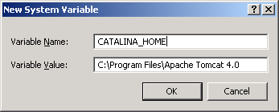

Running Media Server.
Open a browser and use the path: http://wwcs186:8080/dam
Login as dmadmin, enter password and select Login.

